**AWS Lambda**

Amazon released Lambda in 2015 and Lambda is an Amazon Compute service. Which allows you to run code in the Aws cloud without managing servers and we can use create our own back-end services that operates at AWS scale, Performance & Security.

LAB:

Go to the IAM Dashboard

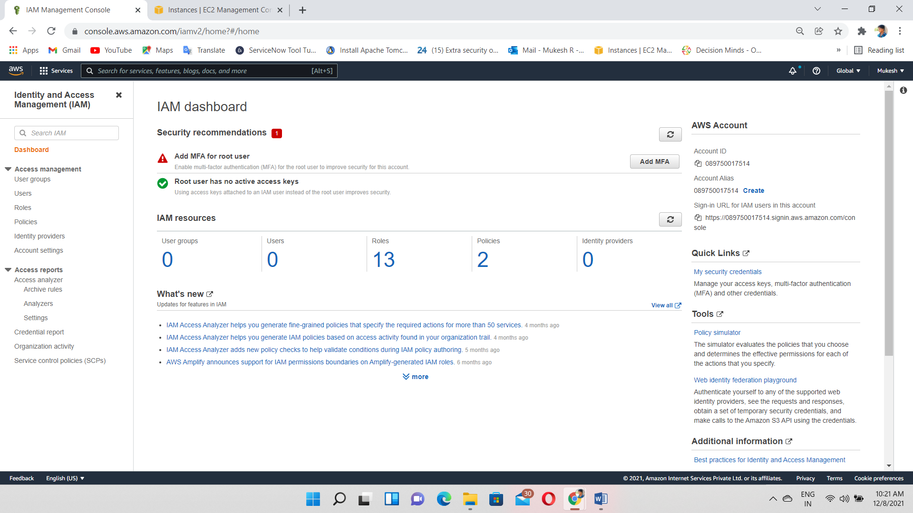

Click on Create Role

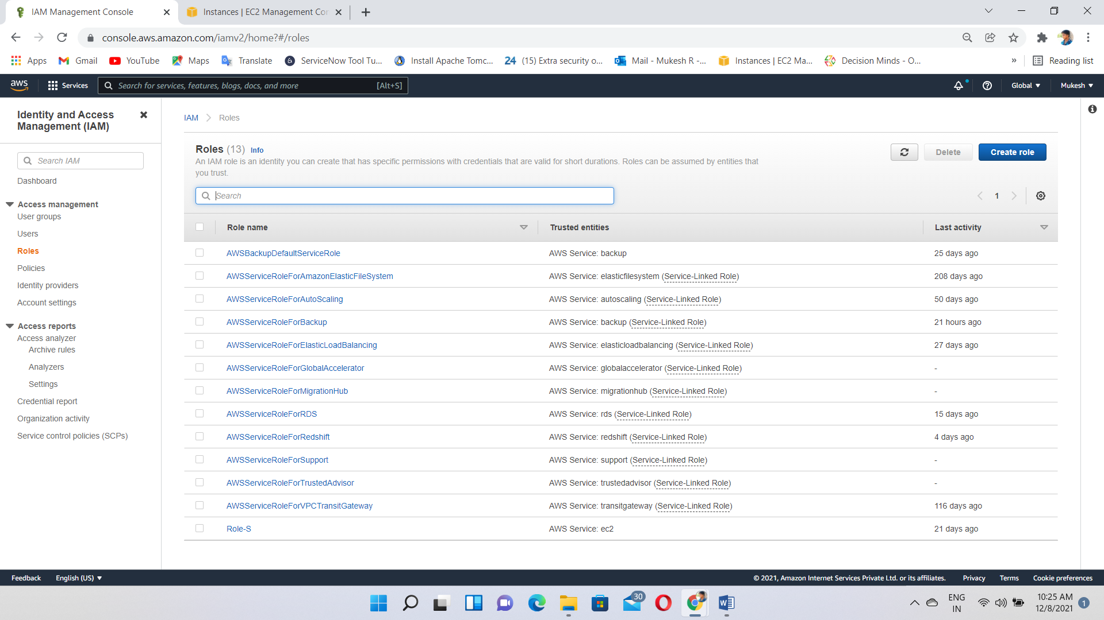

Select the service Lambda

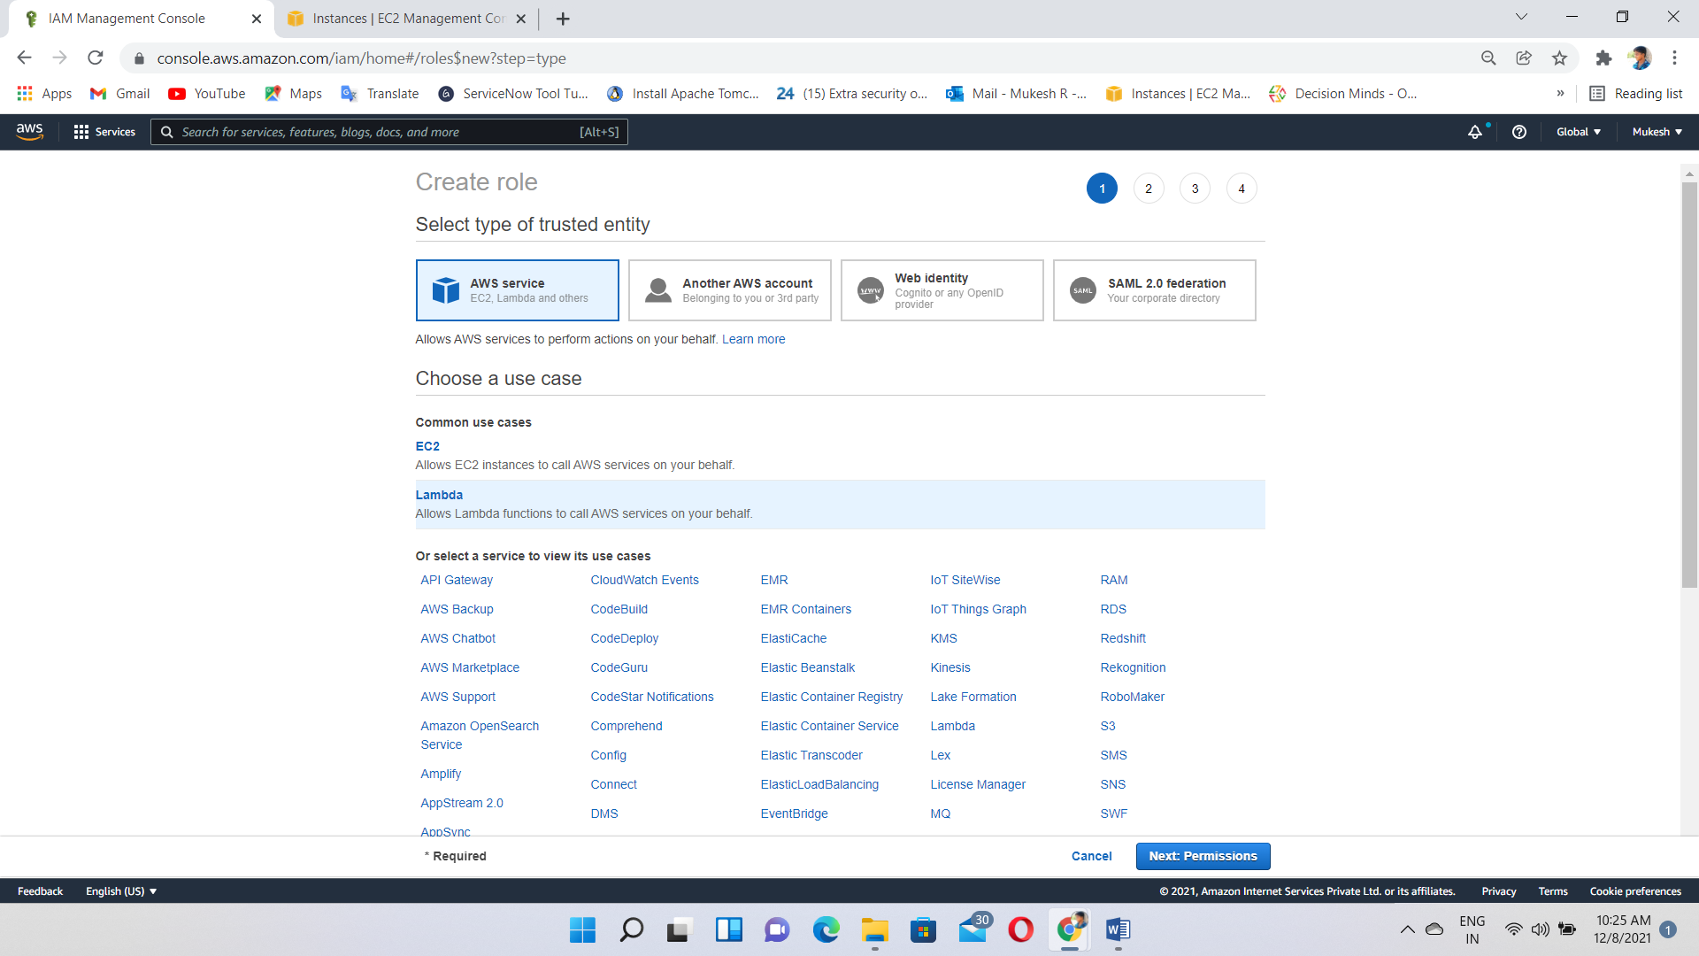

Give a permission “Ec2 full access” to Lambda

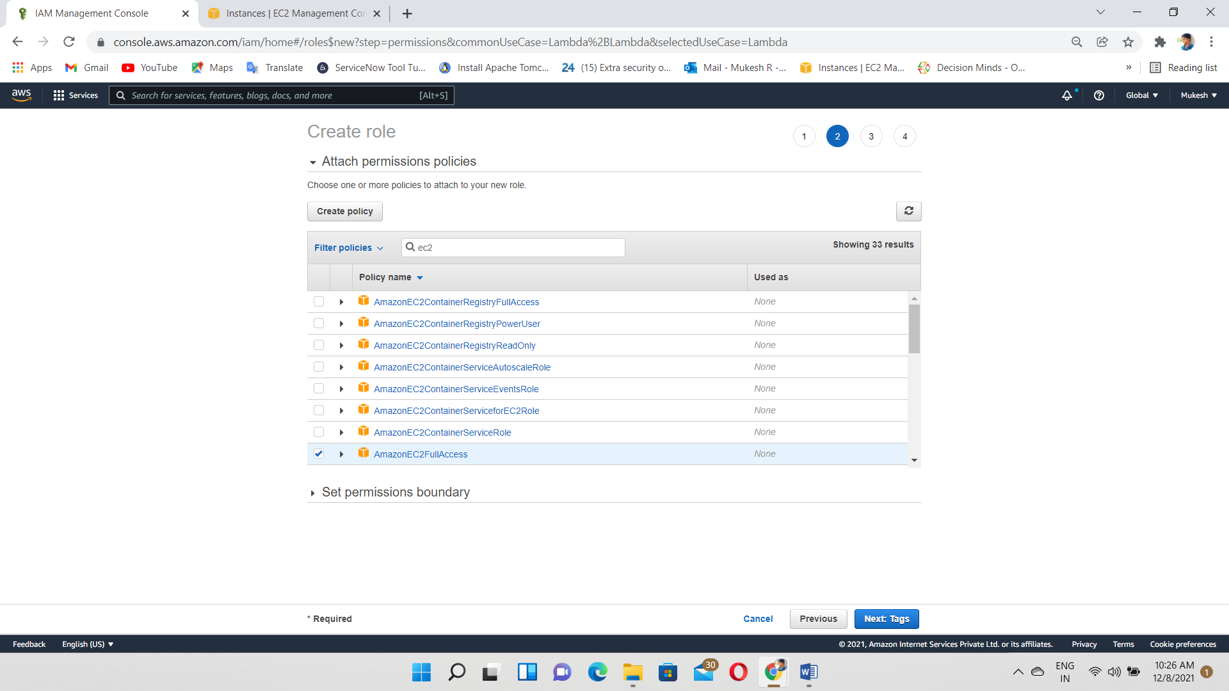

Create an Role

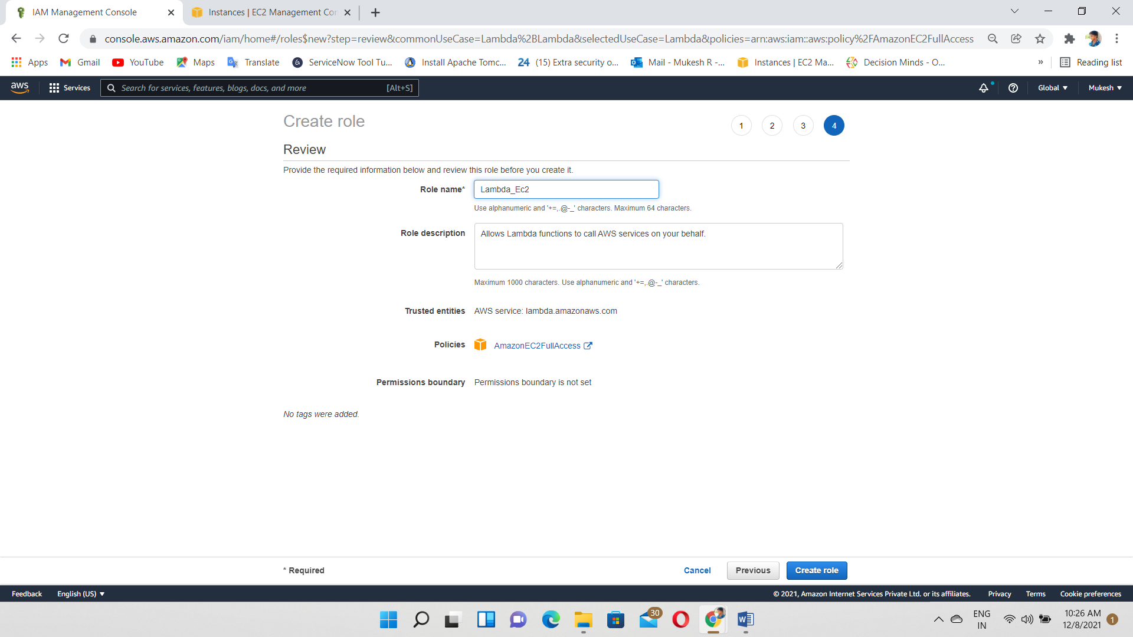

Go to the Lambda Service and Click on Create Function

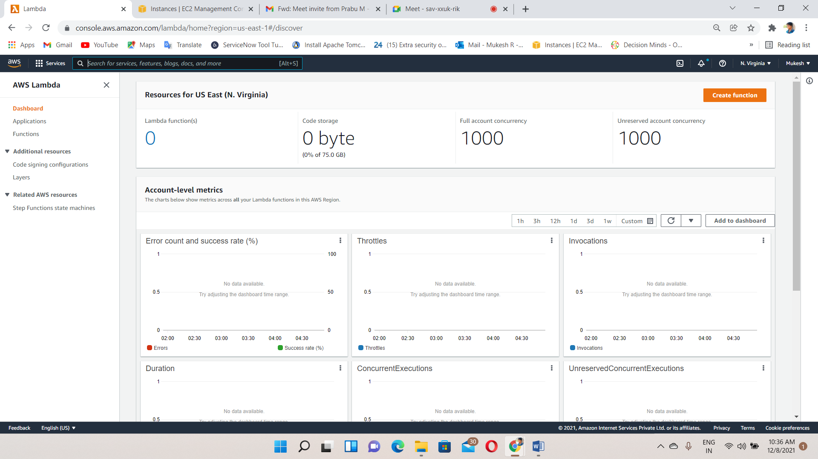

Select ->author from scratch and python 3.7 as runtime

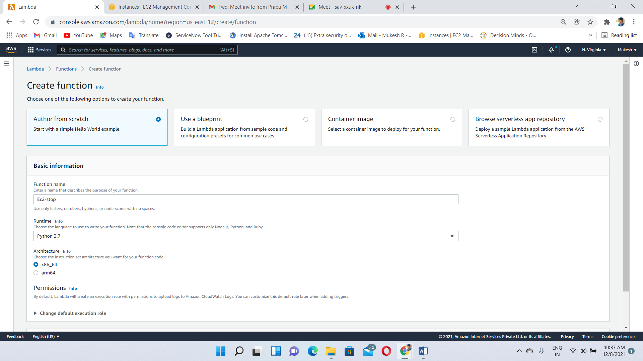

Choose the role I create in 1’st step “Lambda-Ec2”

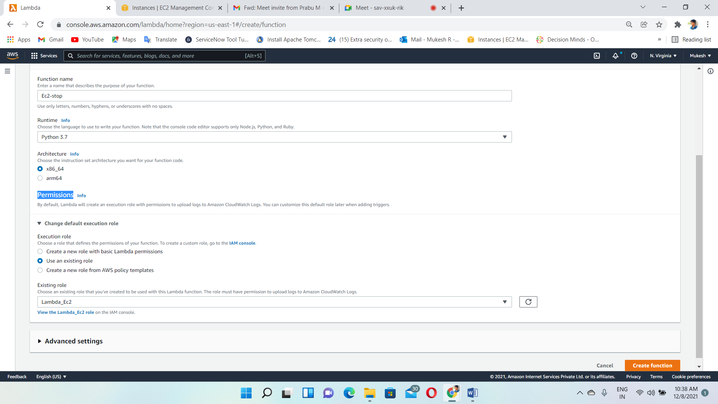

In this page, we need to create a function to stop an instance

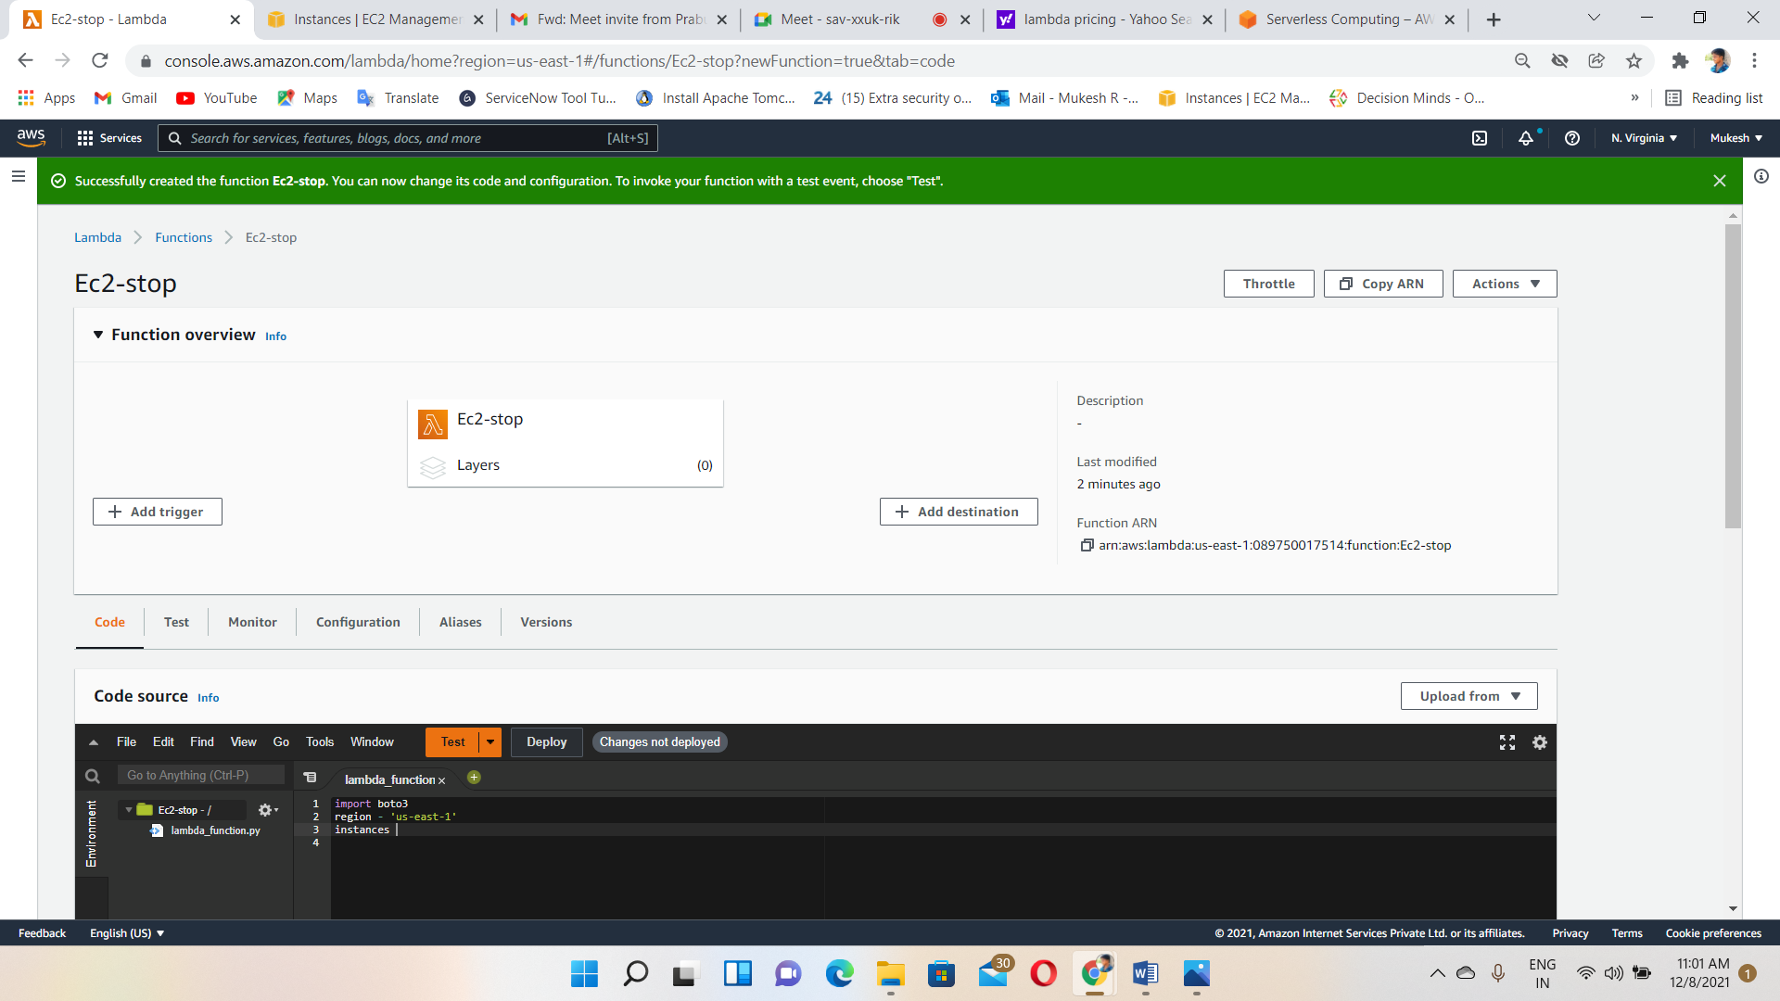

So, we have to create an instance and Go to Ec2 dashboard

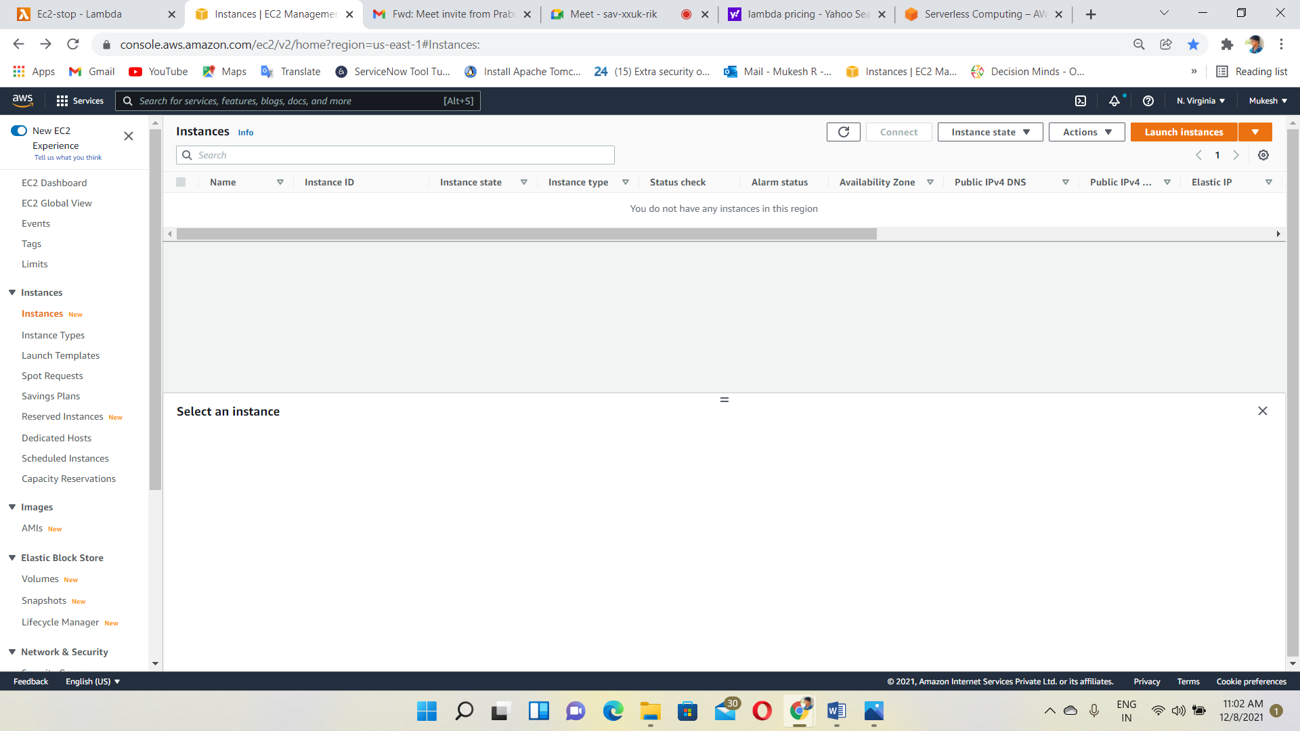

Select an instance we want

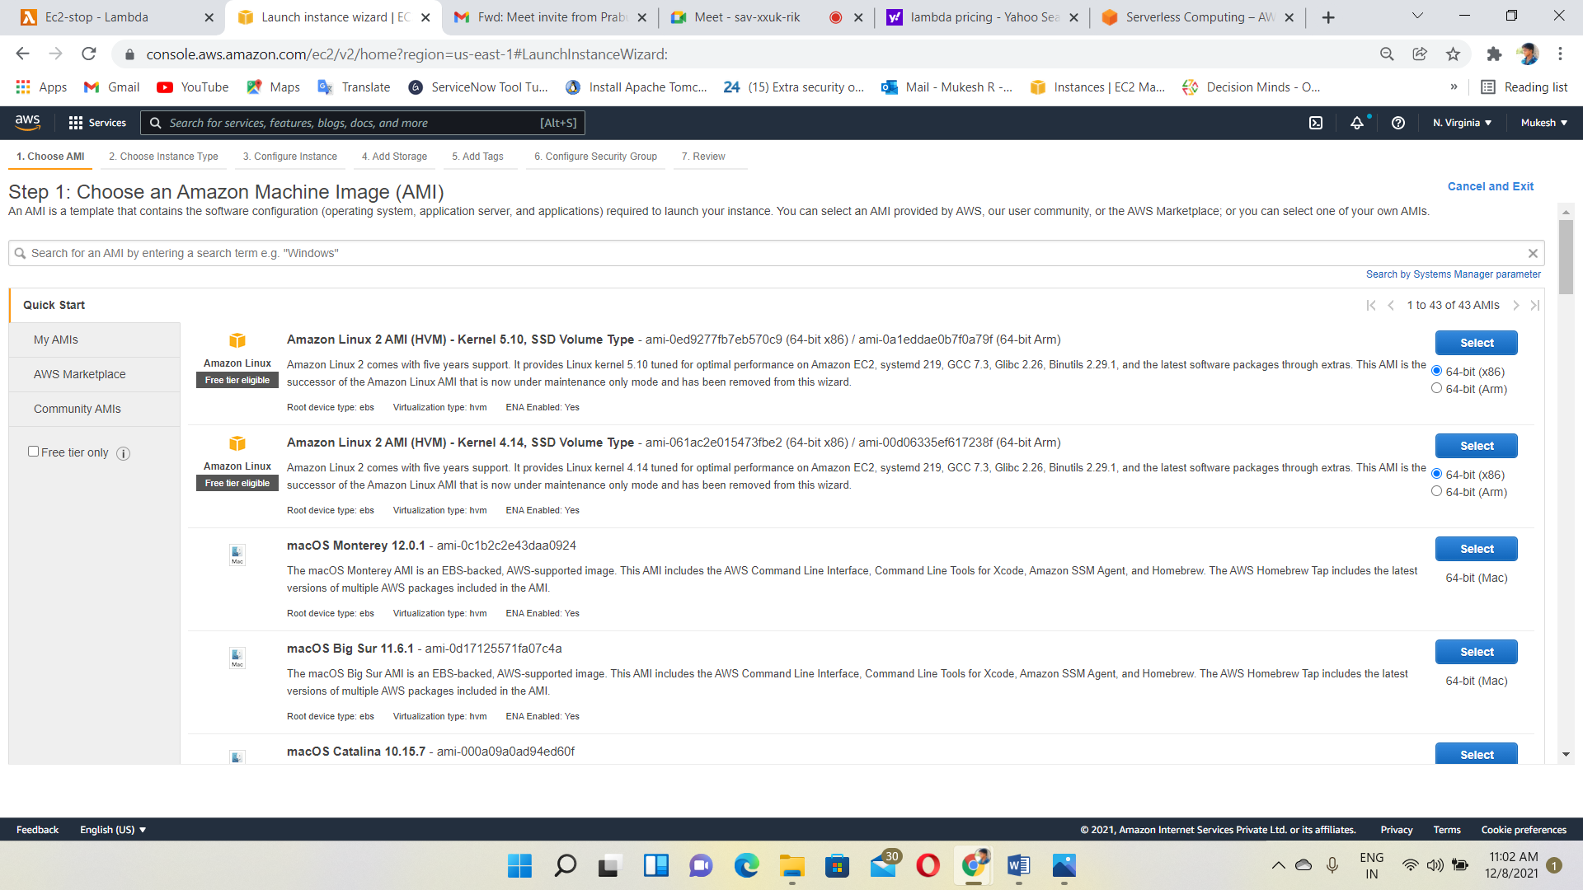

Instance created and status->running

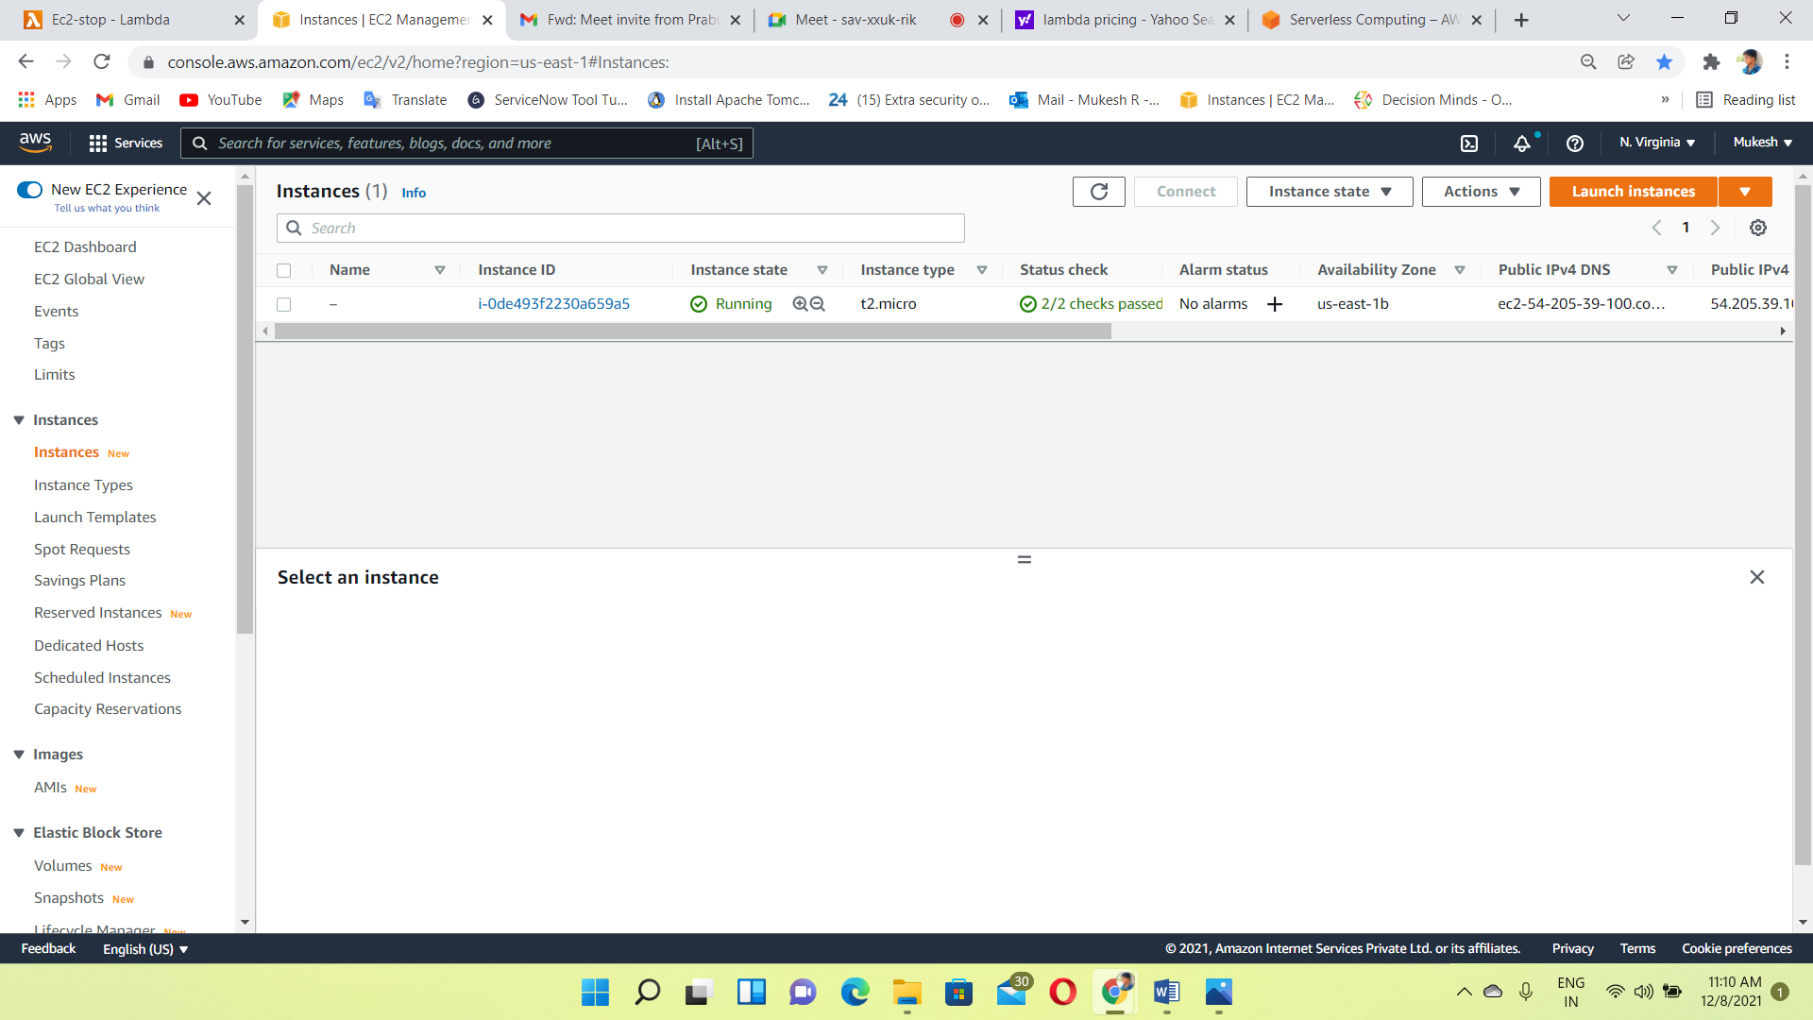

Enter the python function for stop an instance

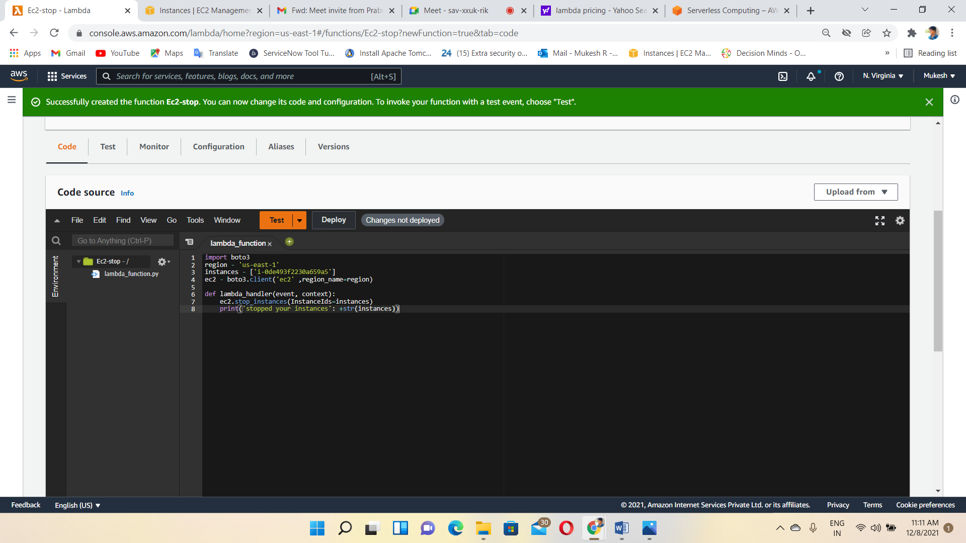

Click on deploy

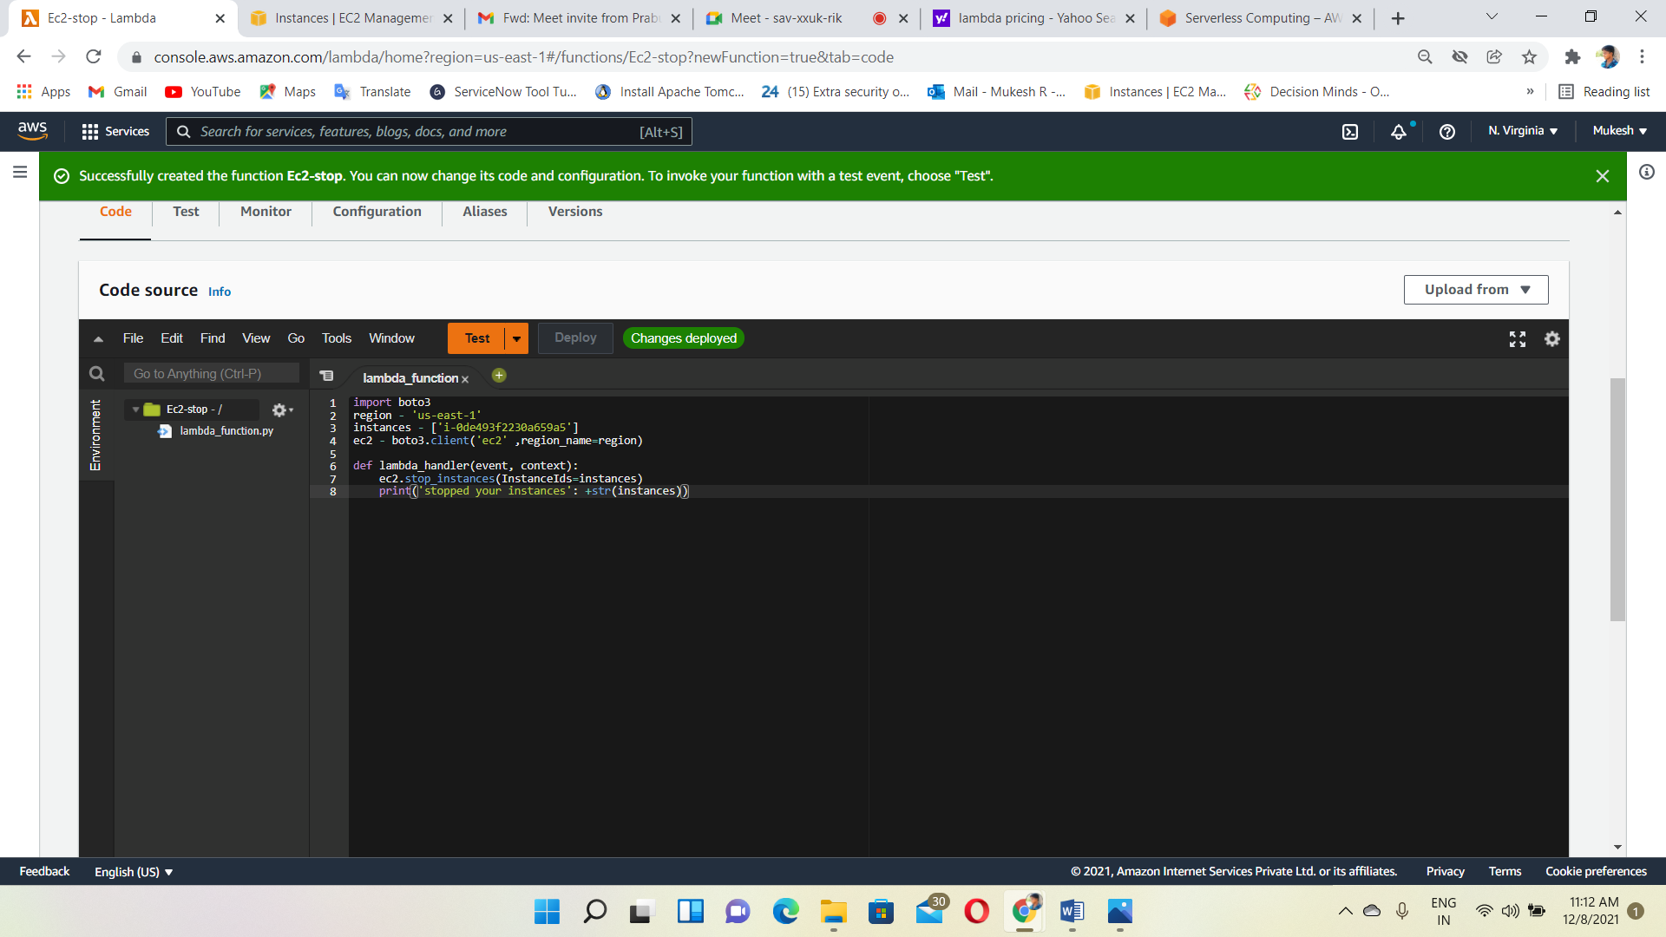

Click on test and then, configure the test event

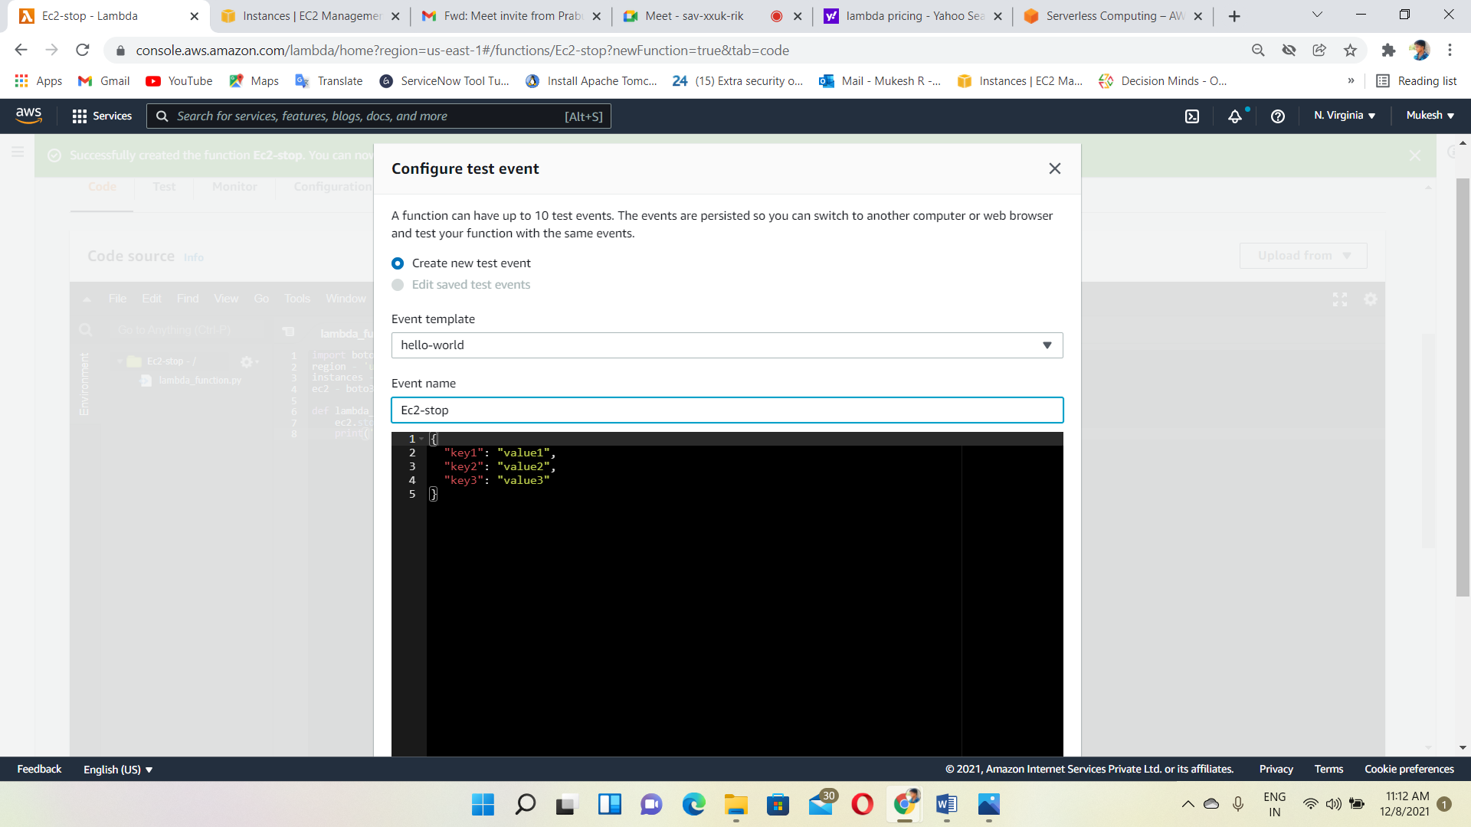

Again, click on test and then, this function executed and status->succeeded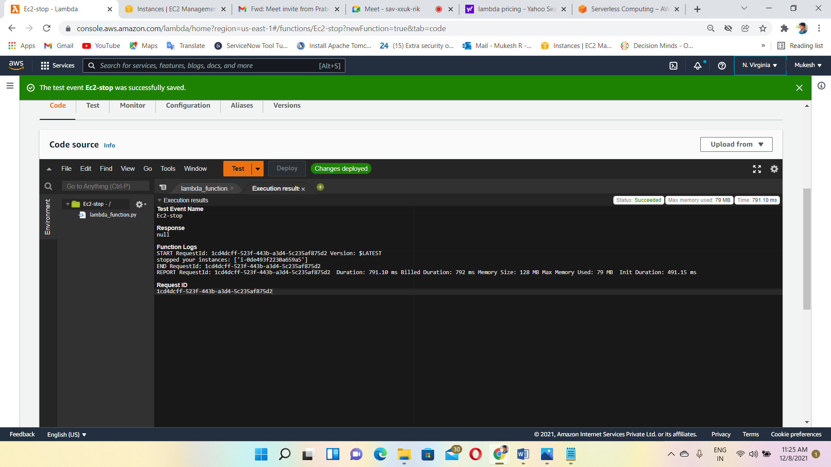

OUTPUT🡪 automatically, instances is stopped according to Lambda Function

